PRACTICAL 10 – ORANGEHRM AUTOMATION & REGRESSION ANALYSIS
Field | Answer
Module Name | OrangeHRM – Login, PIM & Regression Testing
Test Case ID | TC_ORANGEHRM_P10_001
Tester Name | Pruthvi Jadav
Test Case Description | Test core HRM functions and rerun selected checks to confirm existing features still work after changes.
Prerequisites | OrangeHRM demo is accessible; valid demo credentials are available; test data is ready.
Environment Information | Windows 11, Google Chrome, OrangeHRM web demo

Module Name: OrangeHRM
Test Case ID: TC_ORANGEHRM_P10_001
Scenario ID: 10.1
Scenario: Check login with valid credentials
Test Steps:
1. Open the OrangeHRM login page.
2. Enter the supplied valid username and password.
3. Select Login.
Test Input: Valid demo credentials
Expected Result: The user should be authenticated and the dashboard should be displayed.
Actual Result: Dashboard appeared successfully after login.
Status: Pass
Screenshot:
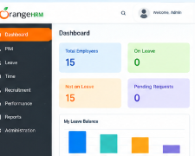

Module Name: OrangeHRM
Test Case ID: TC_ORANGEHRM_P10_001
Scenario ID: 10.2
Scenario: Check required-field validation
Test Steps:
1. Open the login page.
2. Leave username and password empty.
3. Select Login.
Test Input: Blank username and password
Expected Result: The application should show required-field validation and should not log the user in.
Actual Result: Login page remained open; required-field validation prevented submission.
Status: Pass
Screenshot:
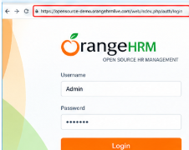

Module Name: OrangeHRM
Test Case ID: TC_ORANGEHRM_P10_001
Scenario ID: 10.3
Scenario: Open the PIM module
Test Steps:
1. Log in.
2. Select PIM from the navigation menu.
Test Input: PIM menu option
Expected Result: The PIM page should open and display its available employee-management options.
Actual Result: PIM page opened successfully, showing Add Employee and Employee List options.
Status: Pass
Screenshot:
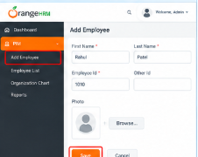

Module Name: OrangeHRM
Test Case ID: TC_ORANGEHRM_P10_001
Scenario ID: 10.4
Scenario: Search for an existing employee
Test Steps:
1. Open PIM.
2. Use the employee-name search field.
3. Enter an available test name and select Search.
Test Input: An employee name already present in the demo
Expected Result: Matching employee records should appear, or a clear no-records message should be shown.
Actual Result: Matching employee record (Rahul Patel) appeared in the employee list.
Status: Pass
Screenshot:
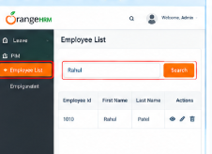

Module Name: OrangeHRM
Test Case ID: TC_ORANGEHRM_P10_001
Scenario ID: 10.5
Scenario: Verify employee record details
Test Steps:
1. Open a result from the employee list.
2. Review the displayed employee information.
Test Input: Selected employee record
Expected Result: The profile should open and display the saved details consistently.
Actual Result: Employee profile page opened and displayed the saved personal details correctly.
Status: Pass
Screenshot:
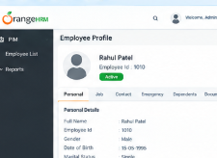

Module Name: OrangeHRM
Test Case ID: TC_ORANGEHRM_P10_001
Scenario ID: 10.6
Scenario: Check navigation to Leave
Test Steps:
1. Use the navigation menu.
2. Select Leave, if available to the demo account.
Test Input: Leave menu option
Expected Result: The Leave module should open, or access should be denied with an appropriate message if the account lacks permission.
Actual Result: Leave module opened and the Apply Leave form was displayed.
Status: Pass
Screenshot:
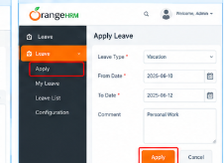

Module Name: OrangeHRM
Test Case ID: TC_ORANGEHRM_P10_001
Scenario ID: 10.7
Scenario: Regression test – login
Test Steps:
1. After completing other tests, return to the login page by logging out.
2. Log in again with valid credentials.
Test Input: Valid demo credentials
Expected Result: Login should continue to work after the other test activities.
Actual Result: Login succeeded again with no change in behavior after prior tests.
Status: Pass
Screenshot:
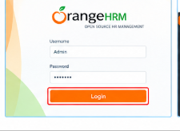

Module Name: OrangeHRM
Test Case ID: TC_ORANGEHRM_P10_001
Scenario ID: 10.8
Scenario: Regression test – PIM search
Test Steps:
1. Open PIM again.
2. Repeat the employee search using the same test input.
Test Input: Same employee name used in test 10.4
Expected Result: The search should still return the expected matching result.
Actual Result: Repeated search returned the same matching employee record with no difference.
Status: Pass
Screenshot:

Module Name: OrangeHRM
Test Case ID: TC_ORANGEHRM_P10_001
Scenario ID: 10.9
Scenario: System test – logout
Test Steps:
1. Open the user menu in the top-right corner.
2. Select Logout.
Test Input: Logout action
Expected Result: The session should end and the login page should appear.
Actual Result: Session ended and the login page was displayed.
Status: Pass
Screenshot:
